**Practice Task:   
GUI Event handling**

Create the following GUI using Java swing components. The exact layout of components is not required. You can use the flow layout.

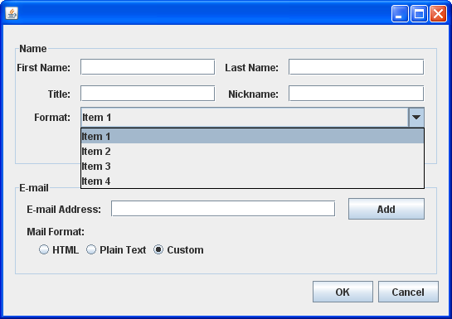

Each text field should be reset (empty string), when it receives focus.

When the email text field loses focus (FocusLost), the program should check the email format as: [part1]@[part2].[part3], where [part1] and [part2] length should be at least 3, and must start with an alphabet. [part3] can be either “com” or “net”. (Hint: you can use the string split function to separate a string into multiple parts)

When the user changes the selection of the dropdown list (combobox), then both title and nickname must b filled with the text of the selected item. For example, if the user selects item 4, then both “Title” and “nickname” should become “item 4”.

When the user clicks the Add button, the following fields data should be added (each on a separate line) to a file named “userdata.txt” (use text files).

* First name
* Last name
* Email

When the user selects the HTML radio button, then the text “Main Format” should be set to following:

* Font: times new roman
* Font size: 20
* Font style: Italic

When either “plain text” or “custom” radio button is selected, the “Main Format” label should be reset to default, i.e.

* Font: serif
* Font size: 12
* Font style: plain

When the ok button is pressed, a message box should be displayed with the following message:

* If any of the text fields on the form is empty, show an error message telling the text fields names which should be filled.
* If all the text fields are filled, then the program should simply display an exit message.